1. Create a script named “myscript” in current directory to do the following.

a) create a dir named “subd1” in current directory

b) create a file named “dircontent” with contents of the current directory

c) display the contents of the file “dircontent”

d) display the contents of a non existing file named “unknownfile”

2. Run the script and validate the output in following cases

a) Redirect only the stdout to an o/p file named stdout.txt

b) Redirect only the stderr to an o/p file named stderr.txt

c) Redirect both stdout and stderr to an o/p file named stdall.txt

d) Display all o/p and error and also redirect both stdout and stderr to an o/p file named stdall.txt

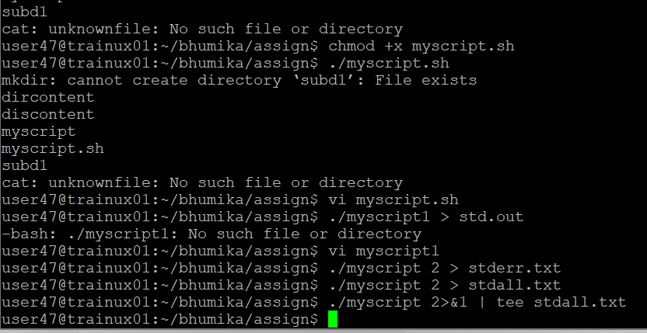

3. Redirect the output of command below using pipe (|) to wc and get the output .

ls -l:w

